Lesson 4 Demo 2: Create a User-Defined Bridge Network

This section will guide you to:

* Create a user-defined bridge network

**Step 1:** Create and delete a user-defined bridge network

*sudo docker network create my-net1*

*sudo docker network rm my-net1*

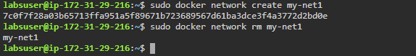

**Step 2:** Connect an *nginx* container to the *my-net* network. Also, publish *port 80* in the container to *port 8080* on the Docker host

*sudo docker create --name my-nginx *

*--network my-net *

*--publish 8080:80 *

*nginx:latest*

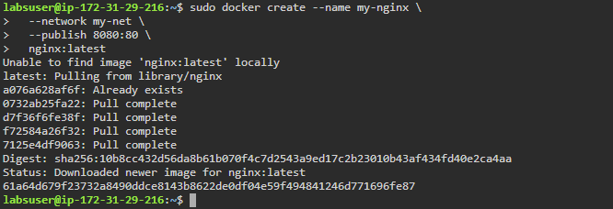

**Step 3:** Connect a running *my-nginx* container to an existing *my-net* network

*sudo docker network connect my-net my-nginx*



**Step 4:** Inspect the *my-nginx* container and check the **Networks**

*sudo docker container inspect my-nginx*

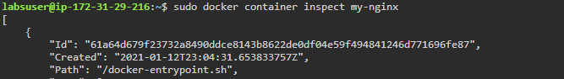

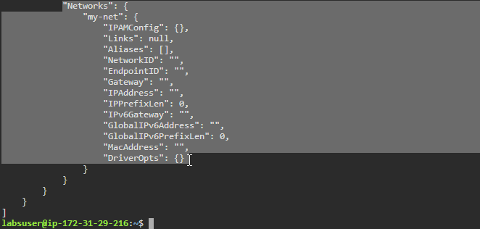

**Step 5:** Disconnect the *my-nginx* container from the *my-net* network

*sudo docker network disconnect my-net my-nginx*



**Step 6:** Inspect the *my-nginx* container and check the **Networks**

*sudo docker container inspect my-nginx*

